A Computer Vision Approach to Ambulance Classification in the Philippines using YOLOv5 Small

STEVE VINCENT PHILLIP C. FERIA

Mapua University, svpcferia@mymail.mapua.edu.ph

ORCID: 0009-0009-5875-7202

JOSE RAFAEL A. FRANCO

Mapua University, jrafranco@mymail.mapua.edu.ph

ORCID: 0009-0005-1051-5520

HANS C. LAGUNA

Mapua University, hclaguna@mymail.mapua.edu.ph

ORCID: 0009-0009-3566-8362

JOHN PAUL Q. TOMAS

Faculty, Mapua University, jpqtomas@mapua.edu.ph

ORCID: 0000-0003-0539-4902

This study outlines the creation of an object detection model utilizing YOLOv5 Small, designed to identify and categorize ambulances on the road, distinguishing them based on various types and characteristics. The research process included the assembly of a specific dataset of ambulance images from the Philippines, which comprised seven classes. The project made use of image augmentation, leading to a dissimilarity score of 0.1574 between the original and augmented images, signifying the successful introduction of variations. The process of hyperparameter tuning was carried out, with a batch size of 8 proving to be the most effective, resulting in a mAP@50 score of 93% for the detection and classification of ambulances and vehicles.

CCS CONCEPTS • Computing methodologies • Artificial intelligence • Computer vision • Computer vision problems • Object detection

Additional Keywords and Phrases: Computer Vision, YOLOv5s, Ambulance Detection and Classification, Philippines Setting

1. Introduction

One of the major problems that the Philippines is continuously facing is heavy traffic. This main problem leads to sub-problems that produce negative impacts on society [19]. A big portion of the medical field is affected, particularly the emergency response vehicles or the ambulances. With this, the study describes the development of an object detection model that uses YOLOv5 Small to detect and classify the ambulances on the road, identifying them based on numerous types and attributes. In this study, the researchers set the following questions that will serve as a guide towards the objectives. (1) Is the YOLOv5s model able to attain high-performance metrics in detecting and classifying different types of Philippine ambulances and their features? (2) By using the Structural Similarity Index (SSIM) to evaluate the dissimilarity between clean and augmented images, what is the average SSIM score, on a scale from 0 to 1, indicating the degree of diversity and non-redundancy achieved in the dataset? (3) By applying hyperparameter tuning, what is the optimal set of hyperparameters that should be used to maximize the performance of the YOLOv5s model?

This study is made to close gaps and open opportunities. These are mainly the opportunity to bring computer vision applications in terms of ambulance classification, the use of a small weight model for YOLOv5, and the opportunity to explore augmentation techniques with different hyperparameter tuning. The main significance of the paper is to make a cost-effective alternative to the traditional way of detecting ambulances and be able to test the best hyperparameter tuning. Furthermore, the study is limited to the utility of the YOLOv5 model with small weight, application of the augmentation techniques of Flip, Hue, Saturation, Brightness, Bluer, and Noise, and hyperparameter tuning which includes the batch sizes for 8, 16, and 32. The dataset will be localized which includes the Philippine ambulances and the three types which are the type I, II, and III.

1. Review of related literature

Related studies have explored different techniques in detecting as well as classifying vehicles with the use of computer vision, YOLOv5 is one of the leading object detection algorithms and it is widely used as it is very successful in the implementation of vehicle detection. Fine-tuning of the YOLOv5 model can enable very accurate classification of vehicles and accurate detection specifically for the application of detecting emergency responding vehicles. Another is the implementation of data augmentation techniques which can expand and help in improving the YOLOv5 model performance.

* 1. YOLOv5 Vehicle Detection

A study of utilizing a Cascade R-CNN with data augmentation to advance autonomous driving capabilities. Advancing vehicle detection is critical for applications like traffic monitoring and autonomous driving. A popular deep learning approach, using techniques like lightweight networks [10], attention mechanisms [12], improved feature extraction [18], and anchor box optimization [11]. Study [10] detected smoke by improving YOLOv5s with MobileNetv3, increasing accuracy by 8.5%. Study [11] optimized YOLOv5s anchor boxes with k-means, boosting mAP 5-6%. Study [12] added attention to YOLOv5, reducing ID-switches by 15%. Study [13] combined YOLOv5 and DeepSORT for real-time traffic analysis at 96-98% accuracy. Improved YOLOv5s for small target detection [14], increasing mAP by 1.6%. Study [15-18] enhanced YOLOv5s for autonomous driving datasets, increasing mAP and precision by 2-5% via attention, feature extraction, and activation functions.

* 1. ERV Detection

Optimizing emergency vehicle response time is critical for traffic management. Strategies like signal preemption [4], route optimization, and computer vision for vehicle detection [6-9] have been proposed. Signal preemption reduced delays by 25-30% [4]. Route optimization and mixed strategies improved practical applications [5]. Deep learning enabled real-time vehicle detection and tracking with high accuracy [6-9]. Together, these optimizations significantly enhance emergency response and intelligent traffic management.

* 1. SSIM Data Augmentation Image Testing

The study [20] explored using data augmentation to improve defect detection accuracy. Researchers have evaluated multiple convolutional neural networks trained on original and augmented image datasets. Another is that a generative technique was used in synthesizing new images for augmentation. Results showed that training on augmented data has increased the defect detection performance across all networks compared to a non-augmented dataset. The study has demonstrated the potential use of generative models and data augmentation in improving a real-world computer vision deployment and application like in manufacturing defect detection.

1. Methodology

This section discusses the process of detecting and classifying Philippine ambulances using the proposed framework. Since there's a lack of research on ambulance detection models specific to this region, the researchers aim to utilize an existing YOLO object detection model with a localized dataset of Philippine ambulances. Collecting the dataset involves considering parameters such as ambulance type, siren lights, and label lettering. The methodology process involves data acquisition, image preprocessing, model training, and performance testing, all to improve ambulance detection through computer vision as seen in **Figure 1.**

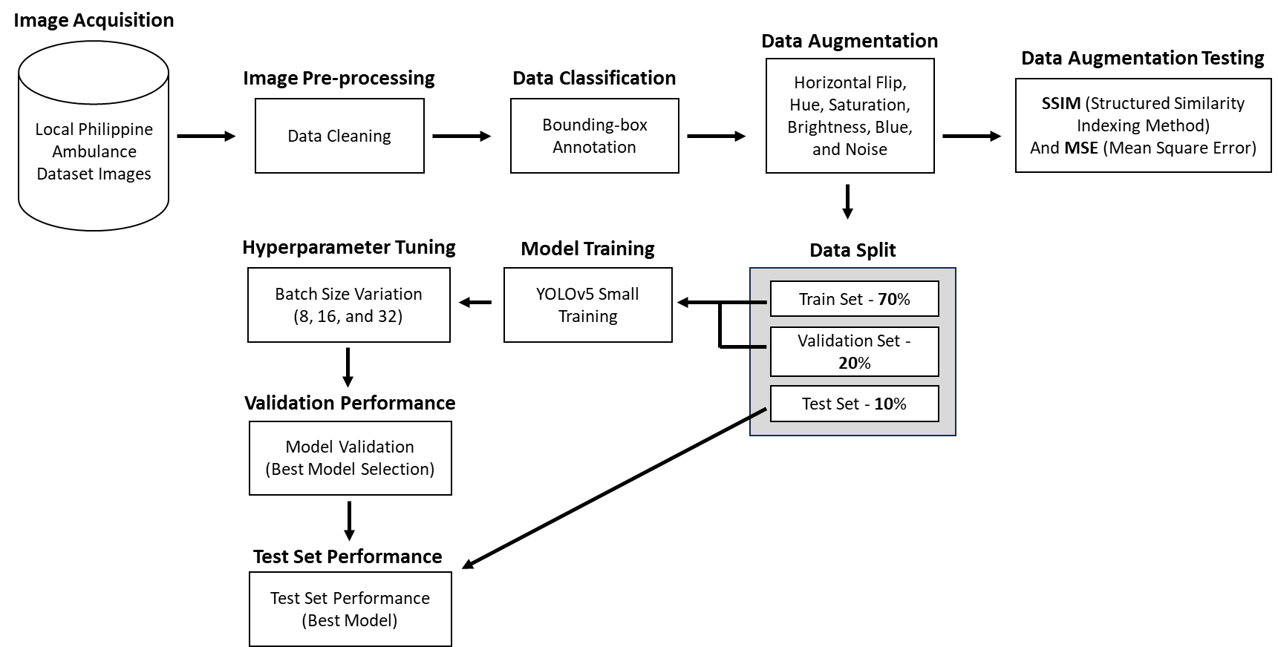

Figure 1: Conceptual Framework.

* 1. Data Acquisition

The image acquisition phase involved systematic image scraping to build a comprehensive dataset of local ambulance images. A custom Python script, utilizing the Selenium web automation library connected to Google Chrome. It initiated a search for "Philippine Ambulance" on Google Images, systematically scrolling down to load image containers. The script automatically opened and downloaded images from each container, ensuring a diverse and representative dataset. The researchers collected 1840 clean images of Philippine ambulances, expanding to 5520 after data augmentation.

* 1. Dataset Overview

The dataset primarily features exclusively Philippine ambulances, specifically Type I, Type II and Type III ambulances commonly equipped with distinctive sirens and labeled "Ambulance." **Figure 2** displays the different types of ambulance types based on their classifications.

* + 1. Ambulance Classification.

Type I ambulances are essentially vehicles constructed from small trucks. The patient compartment, typically box-shaped, is mounted onto the chassis of the truck, with bodies commonly derived from pickup trucks and light-duty trucks. These ambulances can provide Basic Life Support (BLS).

Type II ambulances are predominantly crafted from heavy-duty van units, undergoing minimal modification except for the incorporation of standard ambulance features like emergency vehicle lighting, sirens, and the patient compartment. Type II Ambulances can provide Advance Life Support (ALS).

Type III ambulances share similarities with Type I units, with the distinction that in Type III ambulances, the box-shaped patient compartment is affixed to the chassis of a heavy-duty van rather than a truck.

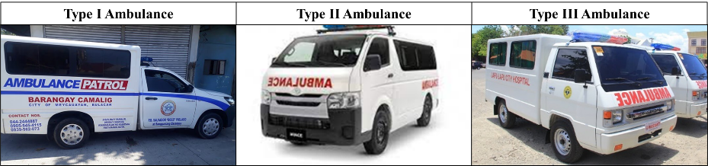

Figure 2: Ambulance Classification

* + 1. Dataset Classes.

The dataset comprises 1,840 images of ambulances, cars, and vans, with each ambulance featuring sirens and "Ambulance" labels. It maintains an even distribution of 368 images per vehicle type to enhance model generalization. This localized dataset is designed for a YOLOv5s model, tailored for precise ambulance detection and classification in the Philippines, making it capable of distinguishing ambulances from visually similar vehicles, and reducing false positives.

* 1. Data Pre-processing and Data Augmentation

The dataset will undergo an initial cleaning phase to remove unsuitable images, including those that are blurry, out of frame, or subject-obstructed. Following this, data labeling will be carried out using the Roboflow platform, where researchers will manually label features like the Ambulance-like chassis, sirens, and "AMBULANCE" labels. The labeled images will then be exported as text files to enable the machine learning classifier to identify specific subjects or features in the images. Refer to Figure 3 for the Roboflow annotation process, which includes labeling a Type II ambulance and its distinctive features like sirens and text.

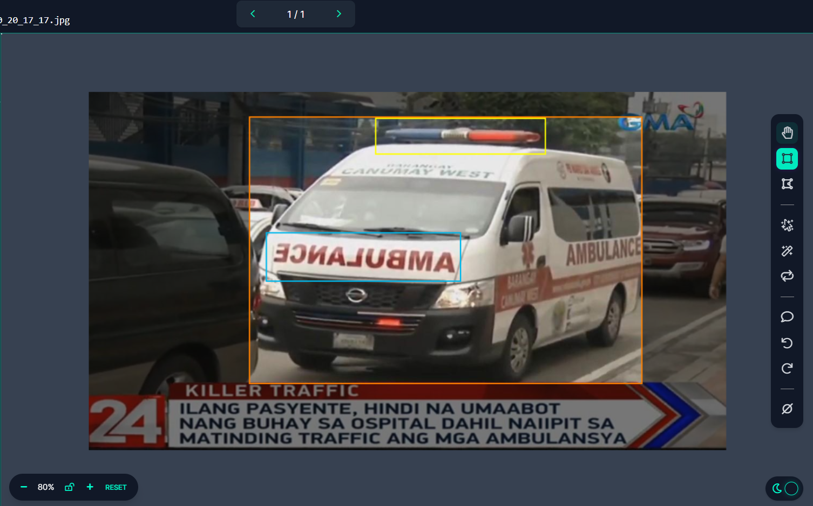

Figure 3: Roboflow Manual Data Annotation of a Type II Ambulance.

Researchers used data augmentation to artificially expand the dataset, enhancing the YOLOv5 model's performance. Various augmentation techniques were applied to create a more robust and diverse dataset, crucial for effective model training. Techniques from article [3] were used for the augmentation of the dataset: Outputs per Training Example (x3): Generating multiple image variations during training enriches the dataset, offering diverse perspectives to the model. Horizontal Flipping: Mirroring images along the vertical axis ensures the model can recognize ambulances regardless of their orientation. Hue Adjustment (-50° to +50°): Varying the hue simulates different lighting conditions, enhancing the model's adaptability to diverse environments. Saturation Modification (-50% to +50%): Adjusting saturation levels adds variability to color intensity, increasing the model's resilience to varying lighting conditions. Brightness Change (-40% to +40%): Modifying brightness levels prepares the model to detect ambulances under different lighting intensities. Blur (Up to 4px): Introducing blur mimics motion or out-of-focus scenarios, aiding the model in recognizing ambulances in dynamic situations. Noise (Up to 10% of Pixels): Adding noise enhances the model's adaptability to images with pixel-level noise, preparing it for real-world clutter and imperfections.

* 1. Data Augmentation Image Testing (SSIM Scoring)

Augmentation techniques play a crucial role in diversifying the dataset, enhancing the model's ability to generalize across various scenarios and variations. However, it's essential to ensure that newly generated images significantly differ from the original dataset. To address this, the use of Structural Similarity Index (SSIM) testing is vital. SSIM serves as a robust metric for quantifying image similarity, with scores ranging from 0 to 1, where 1 indicates perfect similarity. This metric considers various image statistics, such as means (μx, μy), standard deviations (σx, σy), and covariance (σxy) of pixel values. It also includes constants (c1 and c2) to prevent division by zero, set to small values to ensure robustness across diverse datasets (e.g., c1 = (0.01⋅L)², c2 = (0.03⋅L)², with L representing the dynamic range of pixel values) [20]. The SSIM score is calculated as follows:

* 1. YOLOv5s Model Training

After cleaning and augmenting the dataset, the next step was to split it into training, validation, and testing subsets with a standard 70-20-10 ratio respectively. YOLOv5 models come in small, medium, and large weights, each with different complexities. For real-time vehicle detection, YOLOv5 small is the ideal choice, striking a balance between accuracy and speed with a compact size. YOLOv5 small excels in terms of performance, size, and latency, making it the most suitable option among its variations for vehicle detection tasks. The YOLOv5s model training process is systematic and comprehensive, incorporating advanced neural network architecture and optimization techniques [2]. The model will be trained using parameters derived from a previous study that performed hyperparameter tuning [1]. To fine-tune the model's performance, hyperparameters were adopted from a prior study, with an epoch count of 150, three different batch sizes (8, 16, and 32), and a learning rate of 0.001.

* 1. YOLOv5s Structure

YOLOv5s, with its robust architecture featuring CSPDarknet53, PANet, and efficient detection techniques, excels in real-time object recognition. It utilizes Stochastic Gradient Descent (SGD) optimization and strategic Non-Maximum Suppression (NMS) to achieve high precision and operational efficiency. This model, with a focus on critical entities like ambulances, reshapes object detection. **Figure 4** below illustrates the training process.

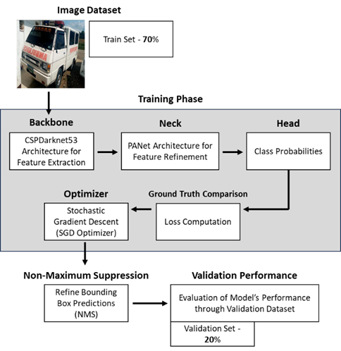

Figure 4: YOLOv5 Training Process

The CSPDarknet53 is the model's backbone, designed for feature extraction. The ambulance image training set passes through this backbone for initial feature extraction [2]. PANet from the neck layer refines and integrates features, enhancing the model's understanding of spatial relationships in the images. It plays a crucial role in recognizing intricate patterns and contextual information, bridging the gap between foundational features and nuanced insights necessary for accurate detection [2]. Refined features from the neck are input into the detection head. Here, the model interprets these representations to make predictions specific to the image dataset's characteristics. For ambulance detection, the head identifies ambulances, classifies types, and recognizes features like sirens and labels, providing actionable insights as the model's output [2]. After passing through the backbone, neck, and head, the ambulance dataset undergoes ground truth comparison and loss computation to assess the model's predictions against annotated information. The Stochastic Gradient Descent (SGD) optimizer fine-tunes the model's weights and biases based on the calculated loss. The optimizer settings, including learning rate, momentum, and weight decay, influence parameter adjustments. The learning rate controls step size in updates, momentum accelerates convergence, and weight decay prevents overfitting. For this study, the learning rate was set to 0.001, momentum to 0.9, and weight decay to 1e-5. Lastly, non-Maximum Suppression (NMS) comes into play after the model's predictions on the image dataset. NMS evaluates predicted bounding boxes, considering confidence scores and overlapping areas (IoU). Boxes with scores below a specified threshold are discarded, and overlapping boxes are refined to ensure the most accurate and non-redundant predictions, optimizing precision, and eliminating duplicate detections.

* 1. Model Validation

The dataset was split into training, validation, and test sets at a 70-20-10 ratio. To assess the model's performance, the validation set is used, focusing on key metrics: mAP@50, precision, and recall. mAP@50 (mean Average Precision at Intersection over Union of 0.5) is a critical metric for evaluating object detection models. It measures the model's ability to rank and retrieve relevant objects, combining precision and recall and considering positive detections that overlap with the ground truth by 50% or more.

Model precision assesses the model's accuracy in correctly identifying ambulances while minimizing false positives. High precision indicates accurate ambulance detection with few false alarms. Precision is determined by the ratio of true positive instances to all positive instances based on the ground truth. The model’s recall is a measure of its ability to detect all the ambulances within a dataset. It is defined as the number of true positives divided by the number of true positives plus the number of false negatives. This means that the recall of the model measures how many of the actual positive cases were correctly identified by the model.

* 1. Model Testing

The model with the highest validation scores, signifying excellent performance and generalization, is selected. This chosen model is then evaluated on a dedicated test set to gauge its robustness and real-world applicability. This evaluation provides a comprehensive assessment of the model's readiness for deployment. Consistent validation metrics, including mAP@50, precision, and recall, are used to test the model on the dataset's test split.

1. Results And Discussions

This chapter presents research findings on ambulance detection and classification in the Philippines, covering the use of the YOLOv5 small-weight model, data augmentation with SSIM testing, and hyperparameter tuning. It includes an in-depth analysis and discussion of the YOLOv5s model's performance in classifying various ambulance types in the Philippines.

* 1. Data Augmentation Dissimilarity SSIM Results

The dataset was augmented by generating three images per original image, and SSIM scores were computed to evaluate the structural differences. The resulting average SSIM score of 0.1574 indicates a high level of dissimilarity among the augmented images, aligning to introduce diversity for better generalization and prevent redundancy in the dataset. The augmentation techniques from article [3] proved successful in creating dissimilar augmented images.

* 1. YOLOv5s Hyperparameter Tuning Validation Performance Metrics

The model was trained after applying data augmentation to the ambulance dataset. The study includes a setup for hyperparameter tuning, with variations for each batch size, namely 8, 16, and 32. The primary goal of the researchers is to identify the best parameter to use with the YOLOv5 small model. After each training and testing phase, a comparison of the validation scores will be conducted to select the most favorable results. As seen in **Table 1** below, the YOLOv5s model that achieved the best overall results was the batch size of 8. The YOLOv5s model with the hyperparameter setting of batch size 8, learning rate 0.001, trained through 150 epochs was selected for the testing phase.

Table 1: Hyperparameter Tuning Validation Results.

|  |  |  |  |
| --- | --- | --- | --- |
| Batch Size | mAP@50 | Precision | Recall |
| 8 | 0.928 | 0.926 | 0.898 |
| 16 | 0.927 | 0.923 | 0.897 |
| 32 | 0.925 | 0.926 | 0.896 |

The model, fine-tuned with a batch size of 8, underwent testing against the dedicated test set of the dataset, resulting in an impressive mAP@50 score of 93% in the accurate detection and classification of ambulances and other vehicles. This outcome highlights the robustness and efficiency of the model in fulfilling its primary objectives. **Table 2** below provides an in-depth look at the model's test results, breaking down its performance across different classes.

Table 2: Model Testing Results.

|  |  |  |  |
| --- | --- | --- | --- |
| Class | mAP@50 | Precision | Recall |
| All | 0.93 | 0.929 | 0.903 |
| Ambulance – Type 1 | 0.974 | 0.961 | 0.987 |
| Ambulance – Type 2 | 0.947 | 0.908 | 0.958 |
| Ambulance – Type 3 | 0.989 | 0.983 | 0.98 |
| Label | 0.823 | 0.832 | 0.736 |
| Misc Vehicle - Car | 0.991 | 0.971 | 0.97 |
| Misc Vehicle - Van | 0.941 | 0.974 | 0.905 |
| Siren | 0.842 | 0.874 | 0.786 |

These results highlight the model's exceptional precision and recall across various categories, signifying its competence in identifying and categorizing ambulances of different types and other objects. With a high mAP@50 score of 93%, the model demonstrates its capability to perform effectively, thus confirming its practical applicability in the realm of ambulance detection and classification. The mean Average Precision (mAP@50) scores are consistently high, with Ambulance - Type 3 topping the list with an impressive 0.989, followed closely by Misc Vehicle - Car with a score of 0.991. These scores indicate the model's precision in recognizing specific objects within the tested classes. The precision scores indicate robust model performance, with Ambulance - Type 3 achieving an extraordinary score of 0.983. The recall scores are also significant, with the Type 3 Ambulance class achieving an impressive 0.998. However, the "Label" class has relatively lower scores in both precision and recall, indicating that there is potential for enhancing detection performance for this class. **Figure 5** below illustrates the YOLOv5s model detecting and classifying ambulances and other types of vehicles using bounding boxes from the test set of the dataset. The necessary features of the ambulance such as its siren and labeling are also detected.

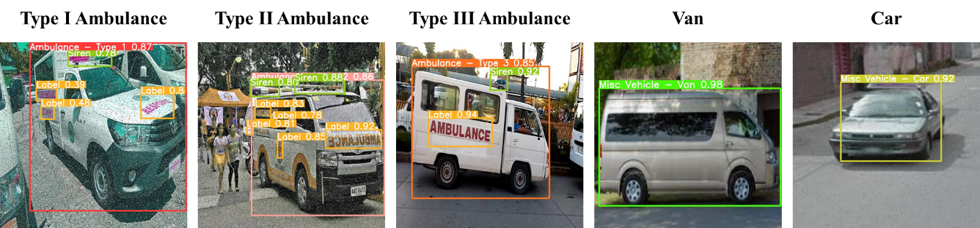

Figure 5: Ambulance classification using bounding boxes.

1. Summary, Conclusion, And Recommendations
   1. Summary

This study aimed to develop an object detection model for classifying ambulances based on their types, utilizing the YOLOv5 Small algorithm for efficient image processing. A localized dataset of 1840 Philippine ambulance images was created using Google image scraping, comprising seven classes: Type I, Type II, and Type III Ambulances, Siren, Label, MISC Vehicle – Car, and MISC Vehicle – Van. The augmented dataset had an average SSIM score of 0.1574, indicating introduced variations. Hyperparameter tuning was performed with batch sizes of 8, 16, and 32, with the batch 8 model achieving the highest mAP@50 score of 92.8% in validation and 93% in testing for ambulance and vehicle detection.

* 1. Conclusion

This study's objectives encompassed classifying different types of ambulances (type 1, type 2, and type 3) and evaluating the YOLOv5 model's performance, with a specific focus on its small weight configuration. The achieved validation and test scores of 92.8% and 93%, respectively, demonstrate the model's proficiency in detecting and classifying Philippine ambulances, fulfilling the first objective. The second objective involved assessing the diversity introduced by augmentation, indicated by a low SSIM score of 0.1574, reflecting successful augmentation. The third objective was hyperparameter tuning, revealing that a batch size of 8 yielded the best results, emphasizing the importance of fine-tuning for optimal object detection using YOLOv5.

* 1. Recommendation

Promising results have emerged in ambulance vehicle detection and classification. Further research is essential to build on and validate these findings. Advanced optimization techniques, such as fine-tuning, transfer learning, or more sophisticated architectures, could enhance the YOLOv5 model's accuracy and efficiency. The study suggests exploring applications for ambulance prioritization at intersections to improve emergency response systems. Creating a more uniform dataset by capturing images under various conditions is crucial for a generalized model. Establishing a system for continuous monitoring and updates will ensure the model's effectiveness in the dynamic environment of Philippine traffic management.

REFERENCES

<bib id="bib1"><number>[1]</number>R. Dey, B. K. Pandit, A. Ganguly, A. Chakraborty and A. Banerjee, "Deep Neural Network Based Multi-Object Detection for Real-time Aerial Surveillance," 2023 11th International Symposium on Electronic Systems Devices and Computing (ESDC), Sri City, India, 2023, pp. 1-6, doi: 10.1109/ESDC56251.2023.10149866.</bib>

<bib id="bib2"><number>[2]</number>X. Song and W. Gu, "Multi-objective real-time vehicle detection method based on yolov5," 2021 International Symposium on Artificial Intelligence and its Application on Media (ISAIAM), Xi'an, China, 2021, pp. 142-145, doi: 10.1109/ISAIAM53259.2021.00037.</bib>

<bib id="bib3"><number>[3]</number>R. Yagfarov, V. Ostankovich and S. Gafurov, "Augmentation-Based Object Detection for Winter Time Applications," 2019 3rd School on Dynamics of Complex Networks and their Application in Intellectual Robotics (DCNAIR), Innopolis, Russia, 2019, pp. 178-180, doi: 10.1109/DCNAIR.2019.8875557.</bib>

<bib id="bib4"><number>[4]</number>R. Anil, M. Satyakumar, and Ameena Salim. 2019. Emergency vehicle signal pre-emption system for heterogeneous traffic condition : A case study in Trivandrum City. 2019 4th International Conference on Intelligent Transportation Engineering (ICITE) (2019). DOI:http://dx.doi.org/10.1109/icite.2019.8880151 </bib>

<bib id="bib5"><number>[5]</number>Weiqi Yu, Weichen Bai, Wenjing Luan, and Liang Qi. 2022. State-of-the-art review on Traffic Control Strategies for Emergency vehicles. IEEE Access 10 (2022), 109729–109742. DOI:http://dx.doi.org/10.1109/access.2022.3213798 </bib>

<bib id="bib6"><number>[6]</number>Muhammad Azhad Bin Zuraimi and Fadhlan Hafizhelmi Kamaru Zaman. 2021. Vehicle detection and tracking using Yolo and DeepSORT. 2021 IEEE 11th IEEE Symposium on Computer Applications & Industrial Electronics (ISCAIE) (2021). DOI:http://dx.doi.org/10.1109/iscaie51753.2021.9431784 </bib>

<bib id="bib7"><number>[7]</number>Xiaohui Guan and Xinxin Sun. 2022. Vehicle identification and traffic statistics system in traffic intersection. 2022 4th International Conference on Intelligent Control, Measurement and Signal Processing (ICMSP) (2022). DOI:http://dx.doi.org/10.1109/icmsp55950.2022.9858960 </bib>

<bib id="bib8"><number>[8]</number>Jiaxing Zhang, Wen Xiao, Benjamin Coifman, and Jon P. Mills. 2020. Vehicle Tracking and Speed Estimation from Roadside Lidar. IEEE Journal of Selected Topics in Applied Earth Observations and Remote Sensing 13 (2020), 5597–5608. DOI:http://dx.doi.org/10.1109/jstars.2020.3024921 </bib>

<bib id="bib9"><number>[9]</number>Yunzhen Wang, Hongbing Ma, and Liangliang Li. 2022. Road traffic vehicle detection method using lightweight yolov5 and attention mechanism. 2022 7th International Conference on Image, Vision and Computing (ICIVC) (2022). DOI:http://dx.doi.org/10.1109/icivc55077.2022.9886525 </bib>

<bib id="bib10"><number>[10]</number>Chengpeng Wang, Huanqin Wang, Fajun Yu, and Wangjin Xia. 2021. A high-precision fast smoky vehicle detection method based on improved Yolov5 Network. 2021 IEEE International Conference on Artificial Intelligence and Industrial Design (AIID) (2021). DOI:http://dx.doi.org/10.1109/aiid51893.2021.9456462 </bib>

<bib id="bib11"><number>[11]</number>Othman O. Khalifa, Muhammad H. Wajdi, Rashid A. Saeed, Aisha H. Hashim, Muhammed Z. Ahmed, and Elmustafa Sayed Ali. 2022. Vehicle detection for vision-based intelligent transportation systems using convolutional neural network algorithm. Journal of Advanced Transportation 2022 (2022), 1–11. DOI:http://dx.doi.org/10.1155/2022/9189600 </bib>

<bib id="bib12"><number>[12]</number>Zhuang Li, Xincheng Tian, Yan Liu, and Xiaorui Shi. 2022. Vehicle tracking method based on attention-yolov5 and optimized DeepSort models. 2022 IEEE 11th Data Driven Control and Learning Systems Conference (DDCLS) (2022). DOI:http://dx.doi.org/10.1109/ddcls55054.2022.9858395 </bib>

<bib id="bib13"><number>[13]</number>Fuheng Guo and Yi Xu. 2022. Vehicle Analysis System based on DeepSORT and yolov5. 2022 3rd International Conference on Computer Vision, Image and Deep Learning & International Conference on Computer Engineering and Applications (CVIDL & ICCEA) (2022). DOI:http://dx.doi.org/10.1109/cvidliccea56201.2022.9824363</bib>

<bib id="bib14"><number>[14]</number>Jiandong Wang, Yahui Dong, Shuangrui Zhao, and Zhiwei Zhang. 2023. A high-precision vehicle detection and tracking method based on the attention mechanism. Sensors 23, 2 (2023), 724. DOI:http://dx.doi.org/10.3390/s23020724 </bib>

<bib id="bib15"><number>[15]</number>Liu Xiaomeng, Feng Jun, and Chen Peng. 2022. Vehicle detection in traffic monitoring scenes based on improved Yolov5s. 2022 International Conference on Computer Engineering and Artificial Intelligence (ICCEAI) (2022). DOI:http://dx.doi.org/10.1109/icceai55464.2022.00103 </bib>

<bib id="bib16"><number>[16]</number>Baoping Xiao, Jinghua Guo, and Zhifei He. 2021. Real-time object detection algorithm of autonomous vehicles based on improved Yolov5s. 2021 5th CAA International Conference on Vehicular Control and Intelligence (CVCI) (2021). DOI:http://dx.doi.org/10.1109/cvci54083.2021.9661149 </bib>

<bib id="bib17"><number>[17]</number>Xuyang Song and Wei Gu. 2021. Multi-objective real-time vehicle detection method based on Yolov5. 2021 International Symposium on Artificial Intelligence and its Application on Media (ISAIAM) (2021). DOI:http://dx.doi.org/10.1109/isaiam53259.2021.00037 </bib>

<bib id="bib18"><number>[18]</number>Lei Shao, Zhenqiang Fan, Ji Li, and Hongli Liu. 2022. Research on road vehicle detection based on improved Yolov5s. 2022 IEEE International Conference on Mechatronics and Automation (ICMA) (2022). DOI:http://dx.doi.org/10.1109/icma54519.2022.9856288 </bib>

<bib id="bib19"><number>[19]</number>Erika Ritzelle Bondoc, Francis Percival Caparas, John Eddie Macias, Vileser T. Naculangga, and Jheanel E. Estrada. 2018. An intelligent road traffic information system using text analysis in the most congested roads in Metro Manila. 2018 IEEE 10th International Conference on Humanoid, Nanotechnology, Information Technology,Communication and Control, Environment and Management (HNICEM) (2018). DOI:http://dx.doi.org/10.1109/hnicem.2018.8666416 </bib>

<bib id="bib20"><number>[20]</number>L. -S. Tseng, C. -H. Wu, Y. H. Chen and C. -H. Tsai, GAN-based Data Augmentation for Metal Surface Defect Detection Using Convolutional Neural Networks. (2023). Ieeexplore.ieee.org. Retrieved October 12, 2023, from https://ieeexplore.ieee.org/document/10219520</bib>